LABASSIGNMENT- 3.1

NAME: G.laxmi pranav HTNO:2303A523403 BATCH: 36

Question1:
Zero-ShotPrompting(PalindromeNumberProgram)
Writeazero-shotprompt(withoutprovidinganyexamples)togenerate aPython functionthat checks whetheragiven numberis apalindrome. Task:
- RecordtheAI-generatedcode.
- Testthecodewithmultipleinputs.
- Identifyanylogicalerrorsormissingedge-casehandling.
CODE:

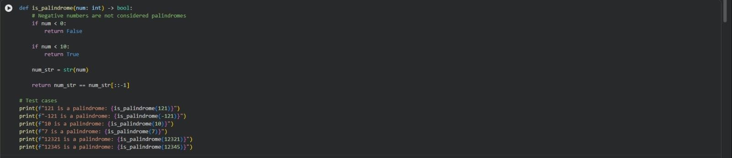
OUTPUT:

EXPLANATION:
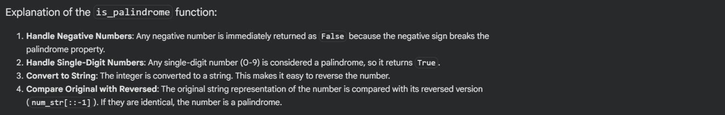

Question2:
One-ShotPrompting(FactorialCalculation)
Write aone-shot prompt by providing one input-output example and asktheAItogenerateaPythonfunctiontocomputethefactorialofa given number.
Example:
Input:5→Output:120 Task:
- Comparethegeneratedcodewithazero-shot solution.
- Examineimprovementsinclarityandcorrectness.
CODE:

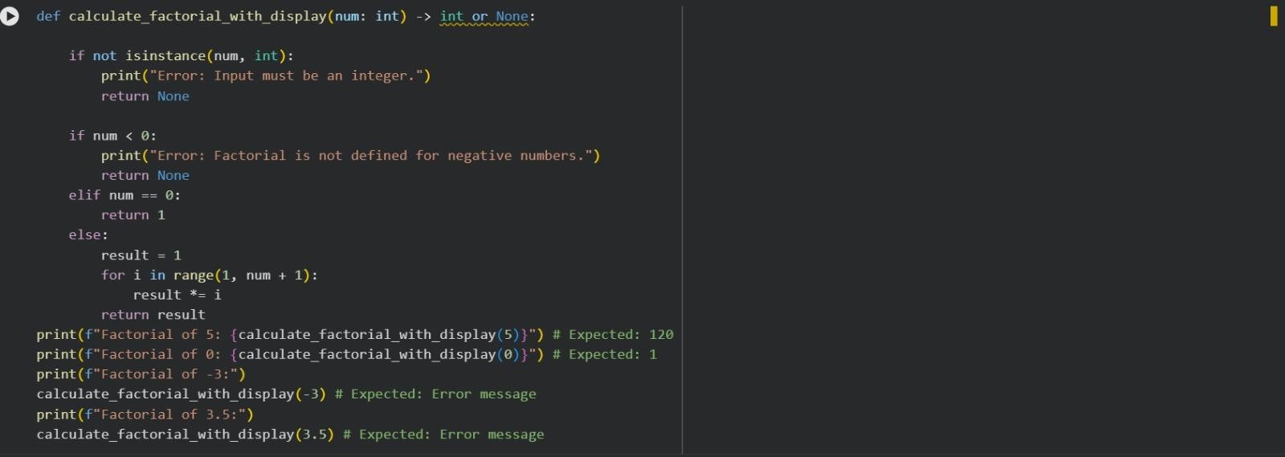
OUTPUT:

EXPLANATION:

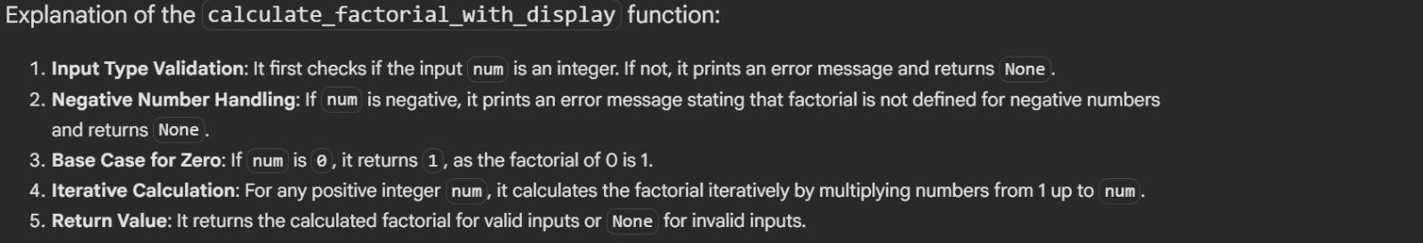

Question3:
Few-ShotPrompting(ArmstrongNumberCheck)

Writeafew-shotpromptbyprovidingmultipleinput-outputexamples to guide theAI in generating a Python function to check whether a given number is an Armstrong number.
Examples:
- Input:153→Output:ArmstrongNumber
- Input:370→Output:ArmstrongNumber
- Input:123→Output:NotanArmstrongNumber Task:
- Analyzehowmultipleexamplesinfluencecodestructureand accuracy.
- Testthefunctionwithboundaryvaluesandinvalidinputs.
CODE:

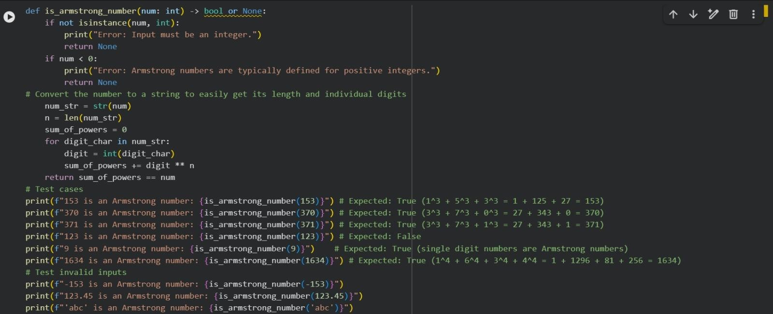
OUTPUT:

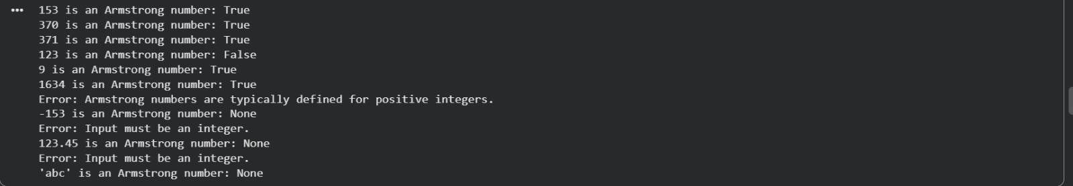
EXPLANATION:

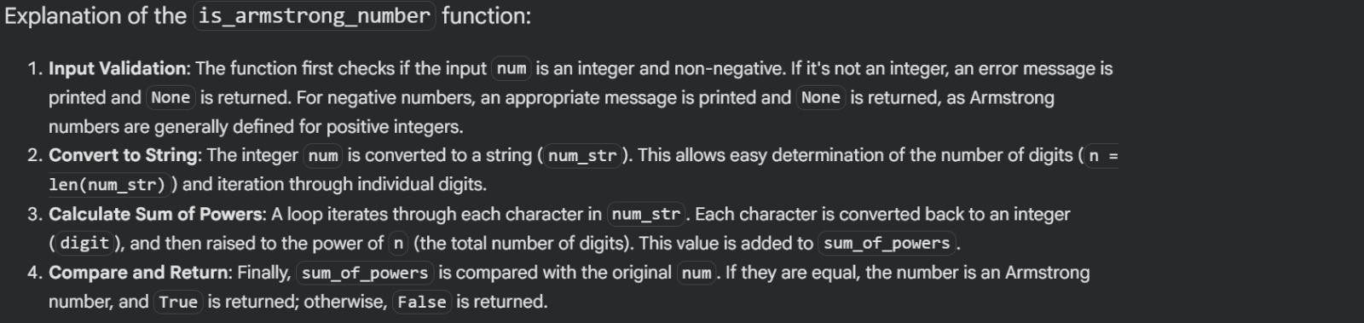

Question4:
Context-ManagedPrompting(OptimizedNumber Classification)
Designacontext-managedpromptwithclearinstructions and
constraintstogenerateanoptimizedPythonprogramthatclassifiesa number as prime, composite, or neither.
Task:
- Ensureproperinputvalidation.
- Optimizethelogicforefficiency.
- Comparetheoutputwithearlierpromptingstrategies.
CODE:

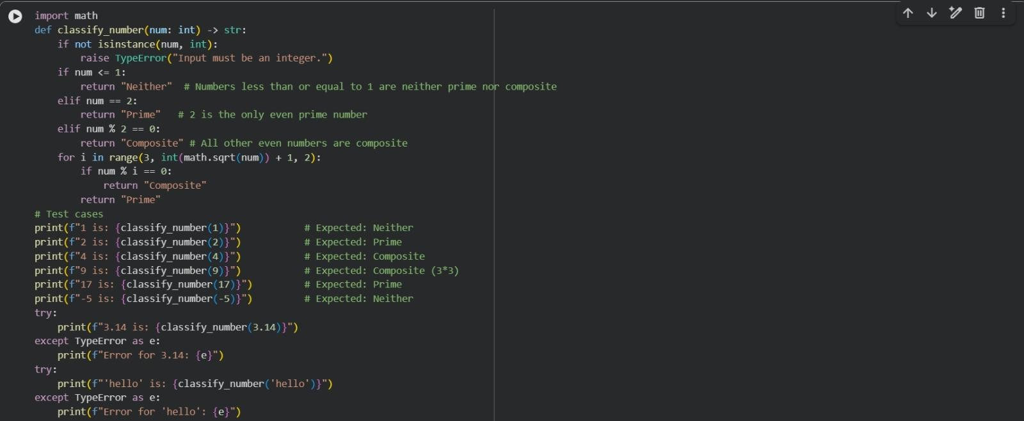
OUTPUT:

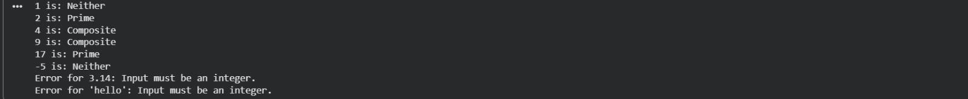
EXPLANATION:

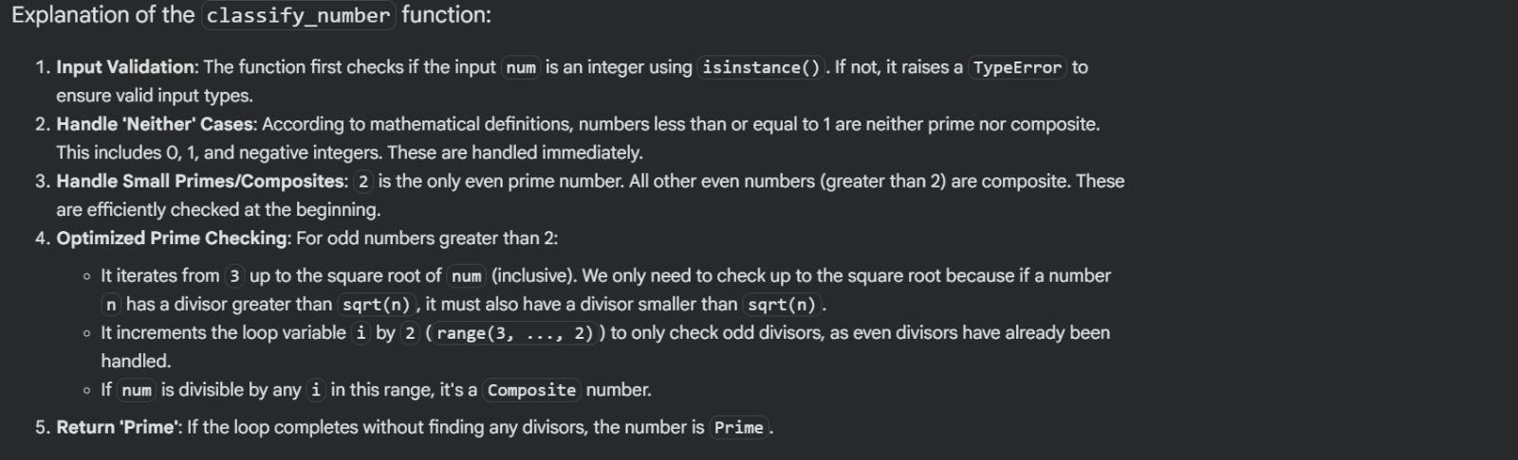

Question5:
Zero-ShotPrompting(PerfectNumberCheck)
Write a zero-shot prompt (without providing any examples) to generateaPythonfunctionthatcheckswhetheragivennumberisa perfect number.
Task:
- RecordtheAI-generatedcode.
- Testtheprogramwithmultipleinputs.
- Identifyanymissingconditionsorinefficienciesinthelogic.
CODE:

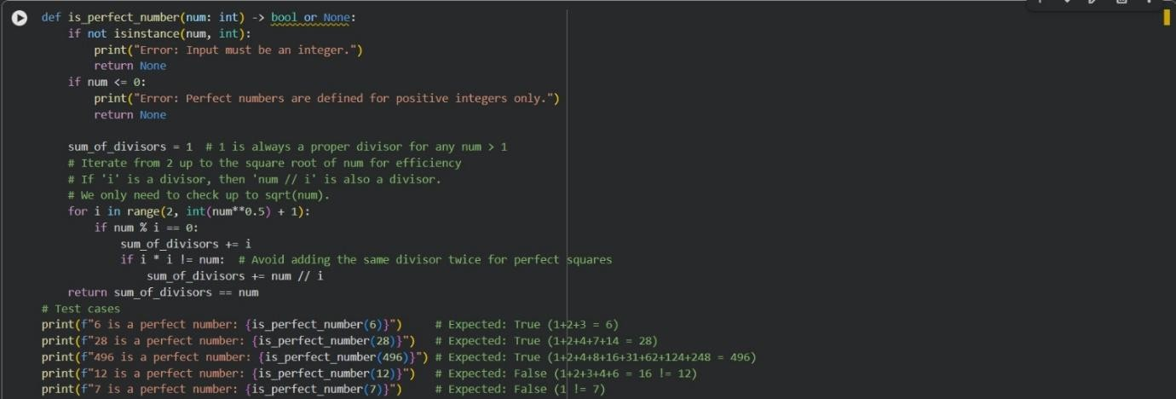
OUTPUT:

EXPLANATION:

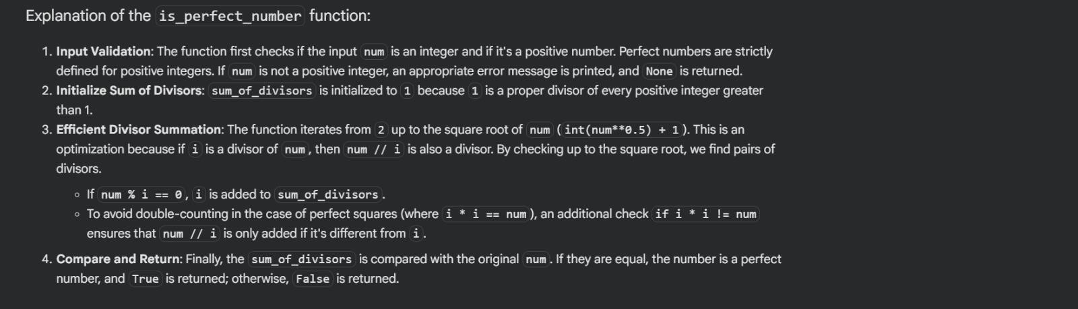

Question6:
Few-ShotPrompting(EvenorOddClassificationwith Validation)
Write a few-shot prompt by providing multiple input-output examplestoguidetheAIingeneratingaPythonprogramthat
determineswhetheragivennumberisevenorodd,includingproper input validation.
Examples:
- Input:8→Output: Even
- Input:15→Output:Odd
- Input:0→Output:Even Task:
- Analyzehowexamplesimproveinputhandlingandoutput clarity.
- Testtheprogramwithnegativenumbersandnon-integerinputs.
CODE:

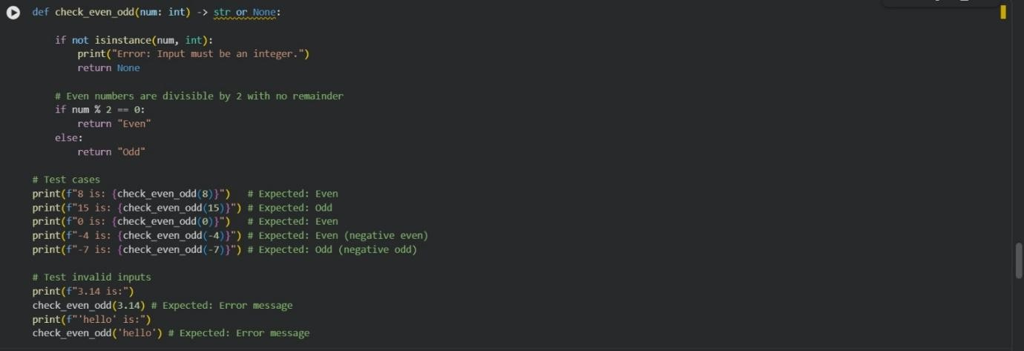
OUTPUT:

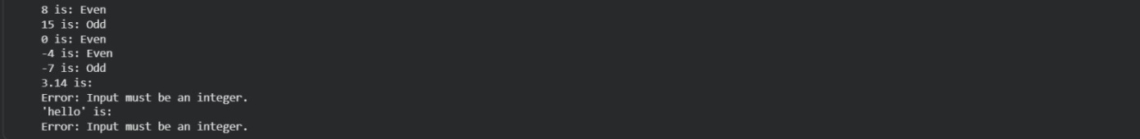
EXPLANATION:
